**DAILY ONLINE ACTIVITIES SUMMARY**

|  |  |  |  |  |  |  |  |  |
| --- | --- | --- | --- | --- | --- | --- | --- | --- |
| **Date:** | **22/05/2020** | | | | | **Name:** | **VIRESH** | |
| **Sem & Sec** | **4th SEM & ‘B’ SEC.** | | | | | **USN:** | **4AL18CS097** | |
| **Online Test Summary** | | | | | | | | |
| **Subject** | | **Operating System** | | | | | | |
| **Max. Marks** | | **30** | | **Score** | | | **25** | |
| **Certification Course Summary** | | | | | | | | |
| **Course** | **Python for Machine Learning** | | | | | | | |
| **Certificate Provider** | | | **Greatlearning academy** | | **Duration** | | | **5 Hrs.** |
| **Coding Challenges** | | | | | | | | |
| **Problem Statement:** Write a C or Java program to implement round robin type of process scheduling. Input: Process with burst time, arrival time and specify the time quantum Output: Processes scheduled based on the round robin type of scheduling, with its average waiting time.  **Problem Statement2:** Write a C Program to implement various operations on Singly Linked List Stack. | | | | | | | | |
| **Status: Executed** | | | | | | | | |
| **Uploaded the report in Github** | | | | | **Yes** | | | |
| **If yes Repository name** | | | | | **Lockdown-Coding** | | | |
| **Uploaded the report in slack** | | | | | **Yes** | | | |

**Online Test Summary: Today 18CS43 test was scheduled from 09:15 am to 09:55am .The portion for the IA was 1st module there were 30 questions and the time assigned was 40 minutes the questions were MCQ type.**

**The snapshot of the completion of the test and the marks allotted is attached here.**

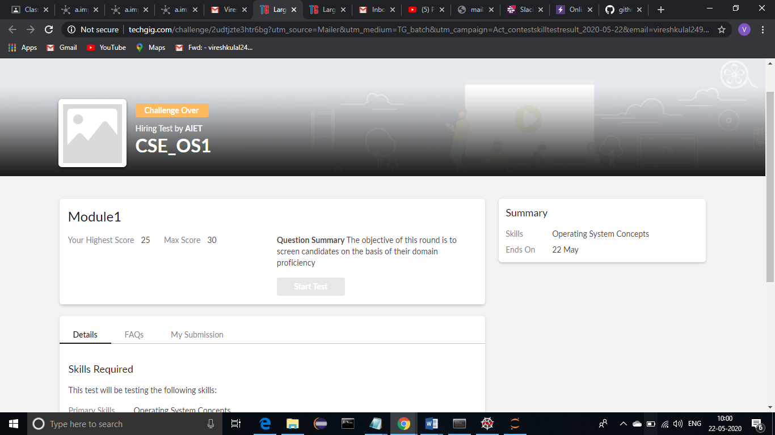

**Online Certification Course Summary: In today’s session I have gone through some other functions in detail which are used in python. After that, I introduced to Numpy and also learnt about the importance of numpy in python and then they explained some numpy Jupiter notebook examples. Then I’ve gone through some previous videos to have a small revision to understand these concepts.**

**The snapshots of today’s course is attached below.**

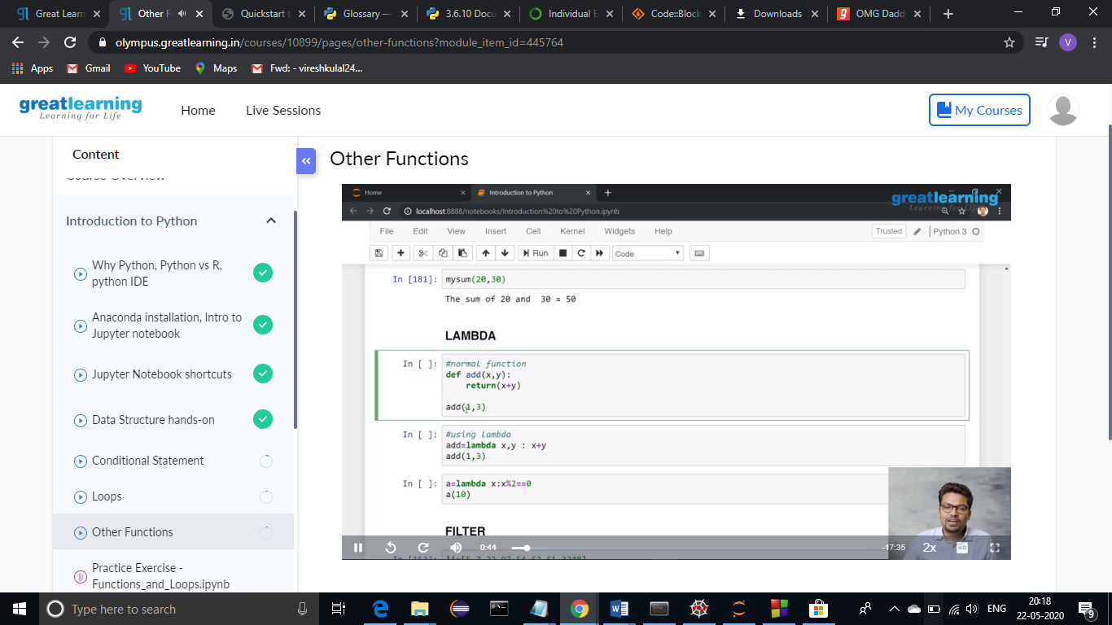

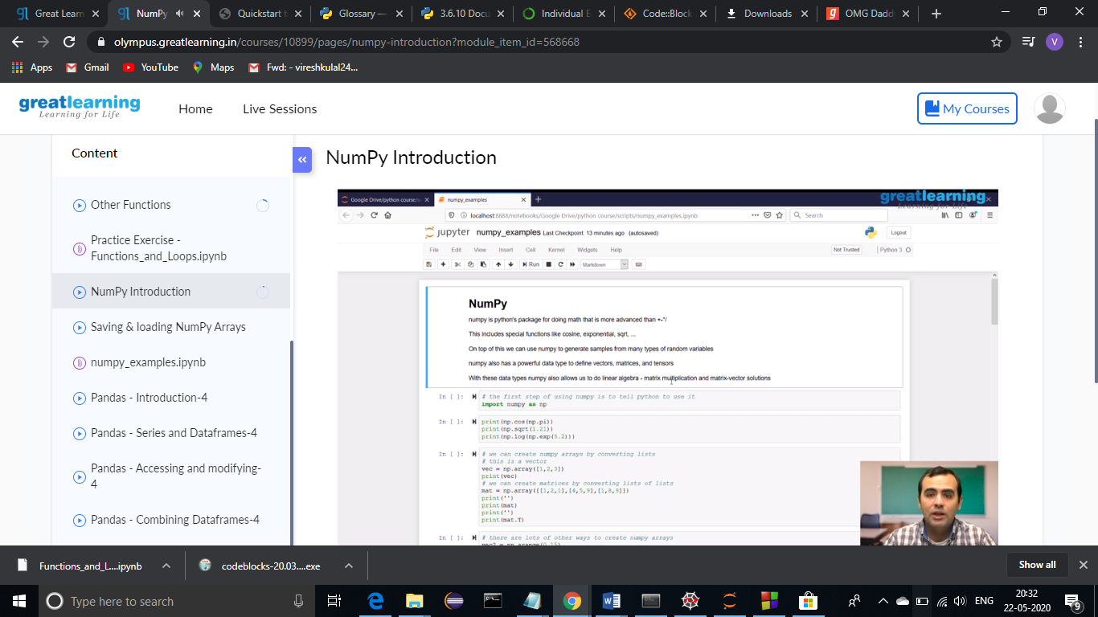

**Online Coding Summary: Today I had received one program from prof. Venkatesh, CSE Dept. and the other from prof. Harshitha G.M CSE Dept. The programs are mentioned above(pg.01). I have uploaded both the programs into my Github repository.**

The Repository Link is: <https://github.com/viresh-kulal/Lockdown-Coding>

And the snapshots of the programs SLLStack.c and RoundRobin.c are attached below.

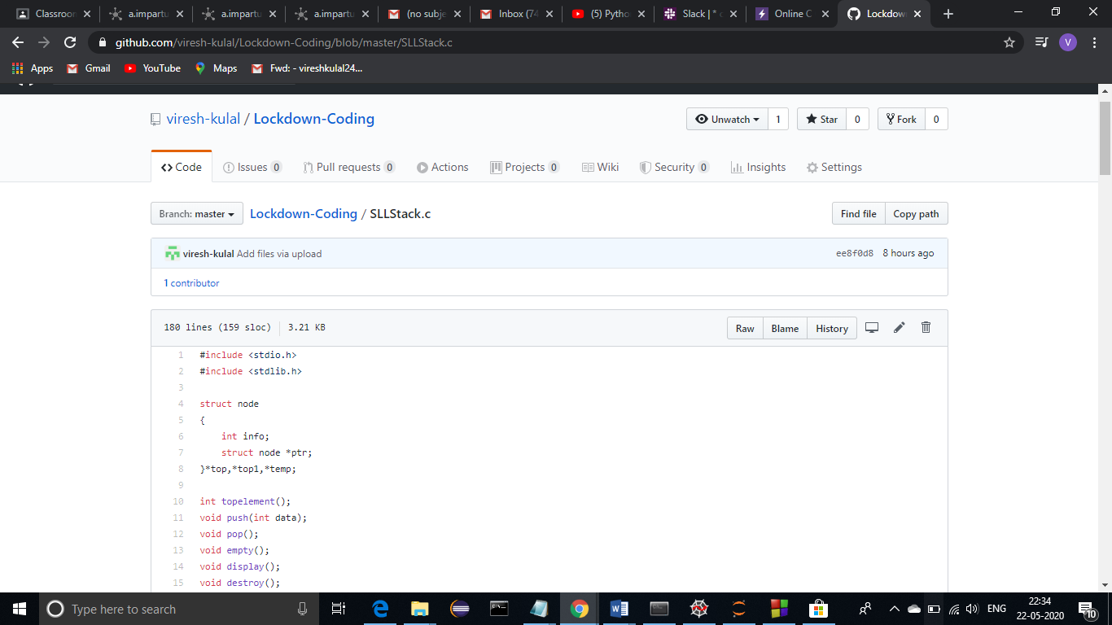

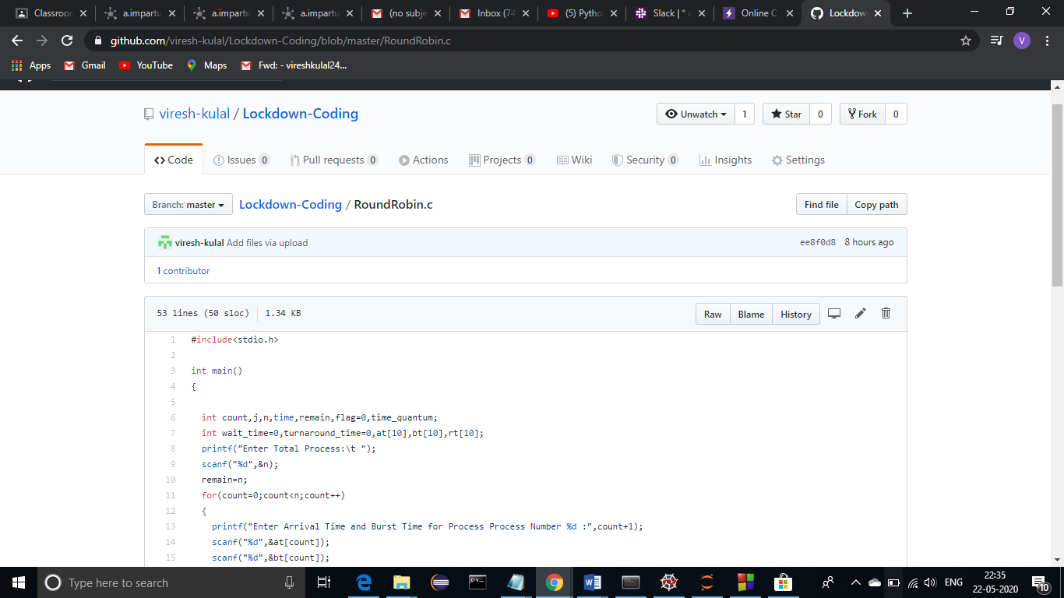

**Thank you.**